**Rat Categorization Project**

The experiment is designed to study categorization behavior in rats. Rats will be shown various shapes and pictures and will have to correctly categorize them in order to receive some reward from a dispenser.

The rat will undergo a series of *trial sequences*. Each trial sequence contains four phases:

1. Star Phase
2. Cue Phase
3. Choice Phase
4. Reward Phase/Correction Phase

In the Star Phase, a star will appear in the center of the screen. If the rat touches the star, the trial proceeds to the next phase.

In the Cue Phase, the rat is shown an *exemplar*. The exemplar is a picture/shape and is in one of two categories ‘A’ or ‘B’. If the exemplar is selected three times, the trial proceeds to the next phase.

In the Choice Phase, the exemplar is shown on either the left or the right side of the screen. Exemplars in category A are supposed to be shown on the left, and B on the right, though they will not always appear this way.

The rat selection triggers the Reward/Correction phase. If the rat selects the exemplar when it is on the correct side of the screen, the rat is rewarded with a food pellet from a dispenser. If it chooses incorrectly, the trial is aborted and starts from the beginning of the sequence.

**Shaping Procedures**

In order for the experiment to be run, the rats must be trained to be able to select items on the screen first. In this shaping part of the experiment, a series of preset sequences are run. There are three phases of the shaping procedure.

Phase 1:

for each trial, 55 in total, 25-minute time limit:

-Star appears on screen for 15 seconds

-if rat touches star, receives reward

-Then, star disappears and is replaced by two white boxes on the left and right for 45 seconds

-if rat touches either box, receives reward

-else, trial is a miss

Phase 2:

for each trial, 55 in total, 30-minute time limit:

-Star appears on screen for 15 seconds

-if rat touches star, it's marked, and it will receive a reward if there are two marks

-else, trial is a miss

-Then, star disappears and is replaced by two white boxes on the left and right for 45 seconds

-if rat touches either box and has touched the star, receives reward

-else, trial is a miss

Phase 3:

for each trial, 60 in total, 25-minute time limit

-Star appears on screen until it is touched

-Once star is pressed, replaced by a white box on the left or right, and black box in the middle

-Black box must be touched 3 times and white box must be pressed once to complete trial

**User Interface:**

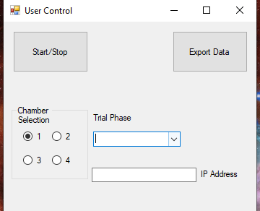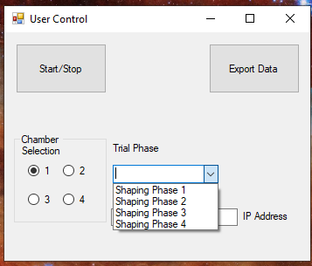

The UI at the moment looks like the picture does above. The user will conduct the experiment in the following order:

1. Select the chamber to be used for the experiment. There are four chambers.
2. Select the Shaping/Trial phase. At the moment, only the shaping procedures are in the combo-box.
3. Input the IP address of the chamber.
4. Select “Start/Stop” the begin the sequence.
5. Once the rat has finished the sequence, the user will be notified that the sequence has been completed. The user will then select the “Export Data Button” and the data collected from the rat display will be sent to an excel spreadsheet.

**Outline of Program:**

There are two projects in the solution. One for the User Interface, and the other for the Rat Display. The Rat Display handles the logic for running the experiment and uses an MVC framework. Trial information is stored in Trial objects which are themselves stored in the Model class. The Controller interacts with the Model class and handles the logic of the program. Output is shown on the RatDisplay form.

The User Interface connects to the Rat Display using TCP sockets. This isn’t something I was familiar with, and I wasn’t able to get working correctly.

The dispenser code is stored on the Raspberry Pi itself and was written by Benjamin Cooper. Interactions between the display and the dispenser are done through the Dispense.py class.

**TODO:**

Most of the functionality of this program has yet to be implemented. Only Phase 1 of the shaping procedure has been completed from the software end.

Items that need to be completed:

-Sending data to-from the Raspberry Pis in the chambers. The basic code has been added to the UI form, this is code carried over from Benjamin Cooper’s Gambling Project which I was previously working on.

-The program will not currently dispense food. The Gambling Project had code for the dispensers that I presume to still work, however the hardware was misconfigured by someone else and not properly reconfigured. I have yet to actually reconfigure it myself. Links to RPI and dispenser information will be provided below.

-The rest of the shaping/trial phases still need to be implemented past Phase 1. Phase 1 is currently triggered from a start button on the screen itself. This needs to be removed and the phase needs to be triggered by the UI.